**Lab Assignment 03**

**Name** : Md. Tasnimul Hassan Khan Rafath

**Student ID** : 21201452

**Section**  : 07

**MYSQL Commands**

After creating the bank database and inserting all the data in the respective tables of the bank database from lab03 data sheet:

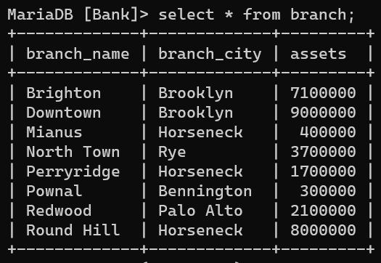

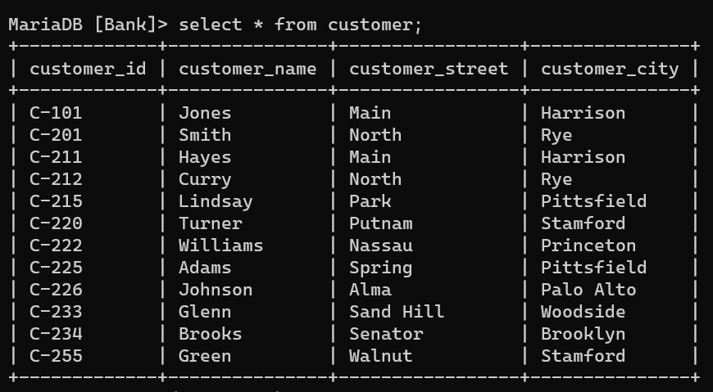

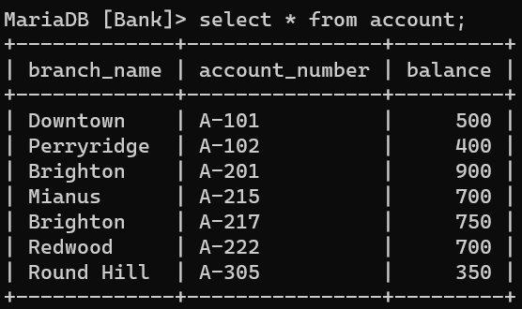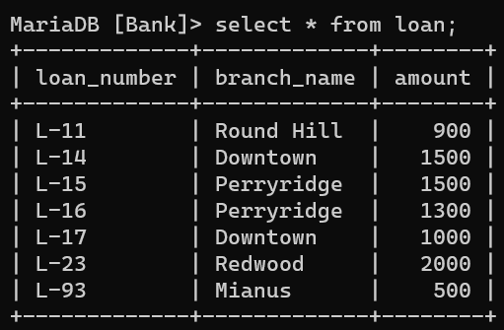

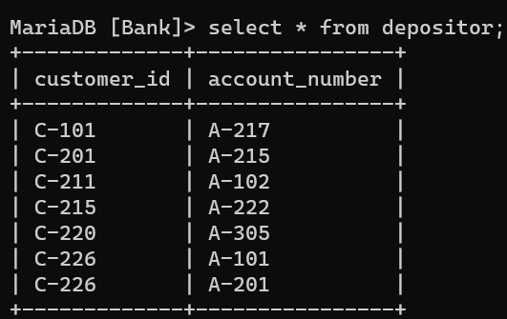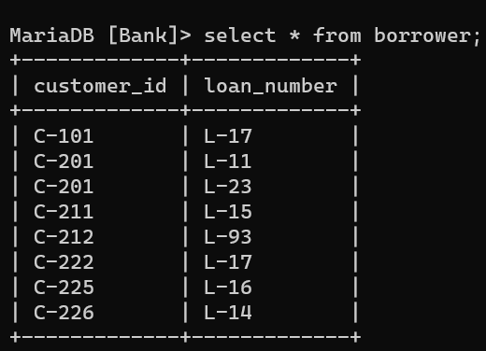

**Task 01:--------**

Select customer_name, borrower.loan_number from ((customer inner join borrower on customer.customer_id = borrower.customer_id) inner join loan on borrower.loan_number = loan.loan_number) where branch_name = 'Downtown' ;

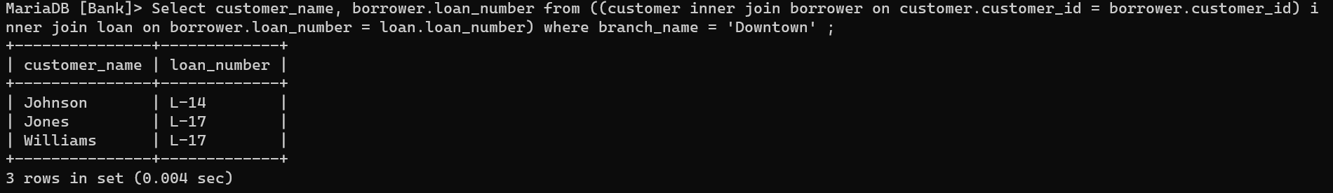

**Task 02:--------**

Select c1.customer_name as Customer1, c2.customer_name as Customer2, c1.customer_city as City from customer c1, customer c2 where c1.customer_city = c2.customer_city AND c1.customer_id < c2.customer_id;

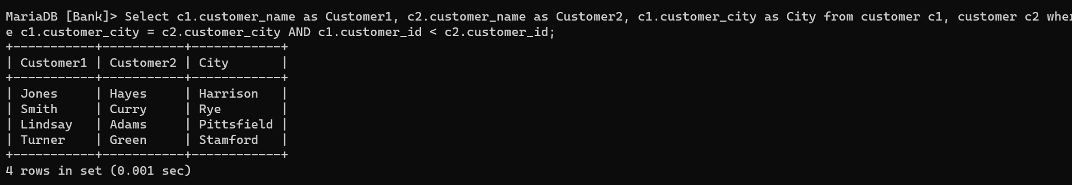

**Task 03:--------**

Select Branch_name, sum(balance * 0.04) as Total_interest from account

Group by branch_name;

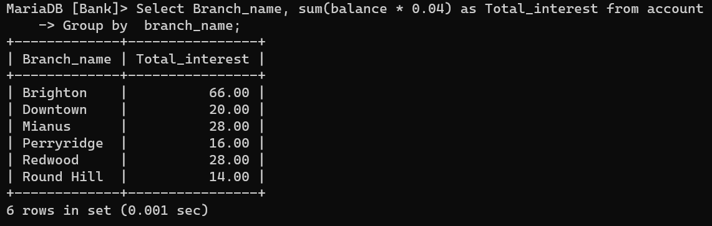

**Task 04:--------**

Select account.account_number, balance, customer_city from ((customer inner join depositor on customer.customer_id = depositor.customer_id) inner join account on depositor.account_number = account.account_number) group by customer_city order by balance desc;

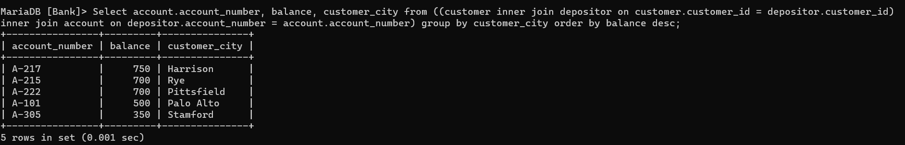

**Task 05:--------**

Select loan.loan_number, amount, customer_name

From ((loan inner join Borrower on loan.loan_number = borrower.loan_number) inner join customer on borrower.customer_id = customer.customer_id) order by amount desc, loan_number desc limit 5;

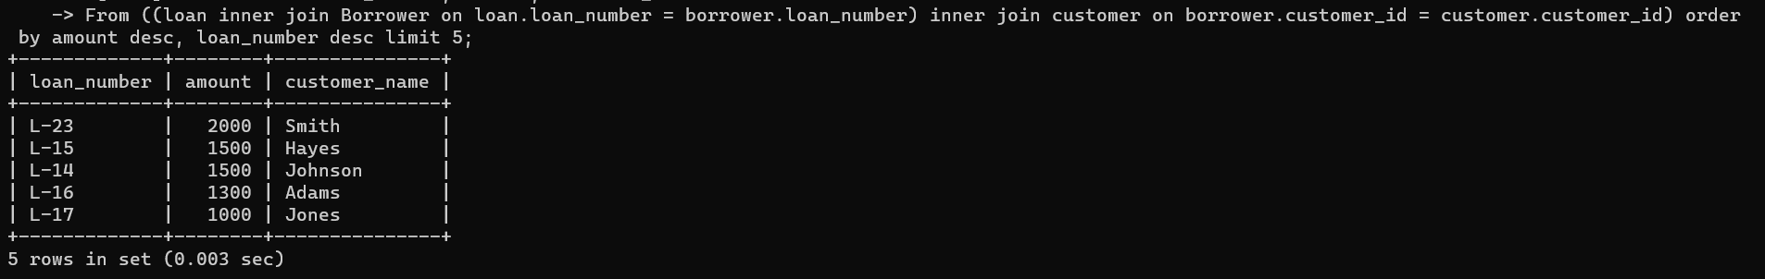**Task 06:--------**

Select customer_name from ((((customer inner join depositor on customer.customer_id = depositor .customer_id) inner join account on depositor.account_number = account.account_number) inner join borrower on customer.customer_id = borrower.customer_id) inner join loan on borrower.loan_number = loan.loan_number) where account.branch_name = 'Perryridge' and loan.branch_name = 'Perryridge';

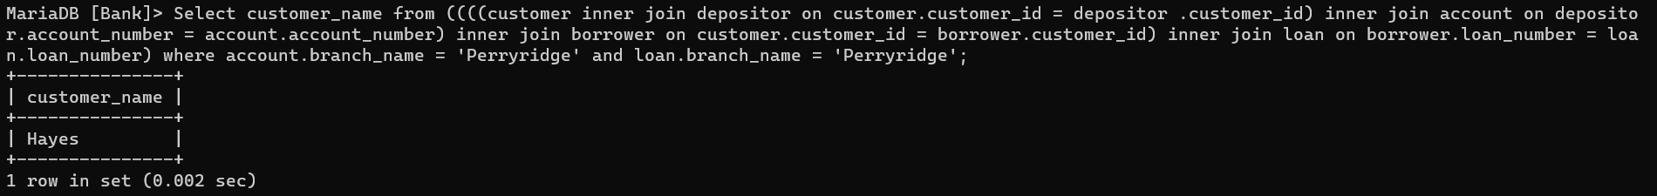

**Task 07:-------**

Select customer_name, sum(amount) as total_loan

from ((customer inner join borrower on customer.customer_id = borrower.customer_id) inner join loan on borrower.loan_number = loan.loan_number) group by customer_name having count(borrower.loan_number) >= 2;

